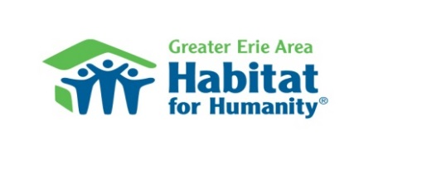
Habitat for Humanity
ReStore Collection Day
Saturday, October 27, 2018 (9 AM to 11 AM)
Location: Wayside Presbyterian Church
1208 Asbury Road, Erie, PA 16505

Items accepted for donation:
(new preferred, or if used, must not be broken, in need of repair, or unusable).
We reserve the right to refuse any item.

Appliances
- Freezers, Refrigerators
- Stoves, Microwaves
- Washers, Dryers
Bathroom/Kitchen
- Cabinets, Cupboards
- Countertops with cabinets below
- Stainless steel sinks only
- Solid surface, corian or granite countertops only
- Medicine Cabinets

Windows
- Thermo-pane vinyl windows
- Shutters

Flooring
- Carpet—New Only
- Hardwood, Linoleum
- Tile, Laminate

Plumbing Items
- Pipe—Copper/Metal/PVC
- Showers/Tubs, Toilets

Lighting/Fixtures
- Chandeliers, Lamps, Indoor, Outdoor

Doors
- Hollow, Metal, Solid, Storm
- Interior/Exterior

Home Goods
- Small appliances, Pictures
- Dishes, Decorative items

Hardware
- Door Handles, Locksets, cabinet handles

Lumber
- Siding
- Lumber pieces at least 6 feet long
- Plywood and OSB full sheets
- Trim/Molding- at least 6 feet long
- Bed Frames, Headboards
- Bookcases, Table/Chair Sets
- Occasional tables

Electrical Items
- Wiring, Ceiling Fans, Lights

Power/Hand Tools

Paint
- Full, unopened cans
- Brushes/Rollers/Trays—New Only

Items not accepted for donation:
Food, clothing, toys, electronics, tires, vehicle parts/supplies. No upholstered items

Customers are welcome to shop the ReStore at 4922 Pittsburgh Avenue; Saturdays from 8 – 4.

